***Round 3***

Read the INSTRUCTIONS before you start !

The design given to you is a single page website.

1. The Output should be as per Design given.

2. All CSS properties should be as per design.

INSTRCTION TO MAKE WEBSITE:

YOU CAN ONLY USE **HTML , CSS and VANNILA JAVASCRIPT** TOCODE THIS WEBSITE

You have to design the given website and also have to make it responsive. It should look properly styled & aligned on all window sizes & devices i.e , desktop , ipad , android etc .

Example: In android , the website should look like this.

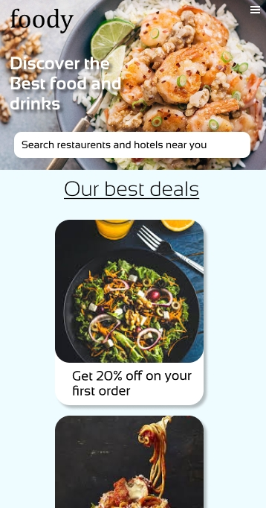

Note: The whole images is provided in website view folder.

Similarly , for other sections , on resizing , website should change its content alignment . But working should be same .

**Top –Right** menu:

After decreasing size , the options (Login SighUp) should disappear and the icon 123.png should visible.

**Search –Bar**:

The search bar should also properly align .

**OUR BEST DEALS** section :

All horizontal deals should align vertical in mobile view.

As this all other items in each section should align themselves properly after changing the size to different devices as shown in given pictures.

Colors:

Background-color: EEFBFF

Buttons- FDB8B8

FONTS:

Heading: cambria

Nav-bar: salsa

Content: sansation, sansation light

Slight different in Design will be considered

You are free to use your creations to make the website more attractive.

All the best!!!